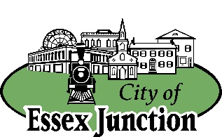
CITY OF ESSEX JUNCTION
CITY COUNCIL
SPECIAL MEETING AGENDA

75 Maple St.
Essex Junction, VT 05452
Saturday, January 31, 2026
11:30 AM

E-mail: admin@essexjunction.org

Phone: (802) 878-6944
www.essexjunction.org

This meeting will be in-person ONLY in the Main Building at Essex Junction Recreation and Parks located at 75 Maple Street.

- CALL TO ORDER [11:30 AM]

- OPEN FORUM
  - Open House Event on the Proposed FY27 General Fund and Capital Budget and Ballot Articles – there will be no formal presentation. Any time between 11:30am and 2:00pm community members can stop by to learn, ask questions and provide input on the budget and proposed Annual Meeting ballot questions before it’s finalized.
- ADJOURN

Upcoming City Council Meetings
(Meeting Dates are Subject to Change)
(* denotes special meeting or date change)

 | *March 23, 2026 | May 13, 2026
February 11, 2026 | March 25, 2026 | May 27, 2026
February 25, 2026 | April 15, 2026 | June 10, 2026
March 11, 2026 | April 29, 2026 | June 24, 2026

